- Environment Verification
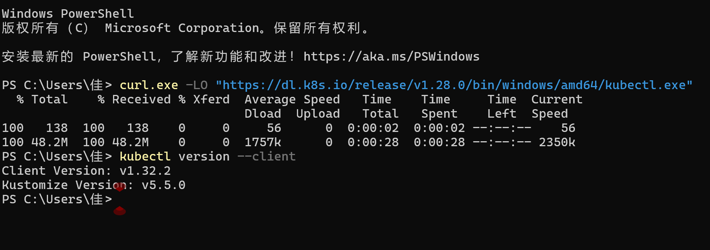
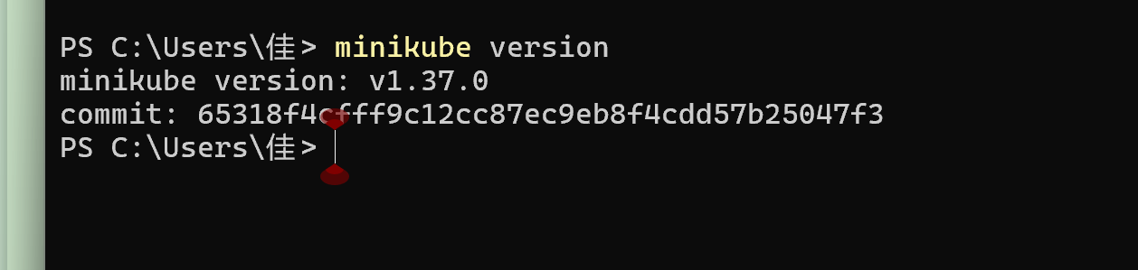
- Experiment 1: Hello Minikube (Deploying a Sample Application)
- Start Minikube cluster
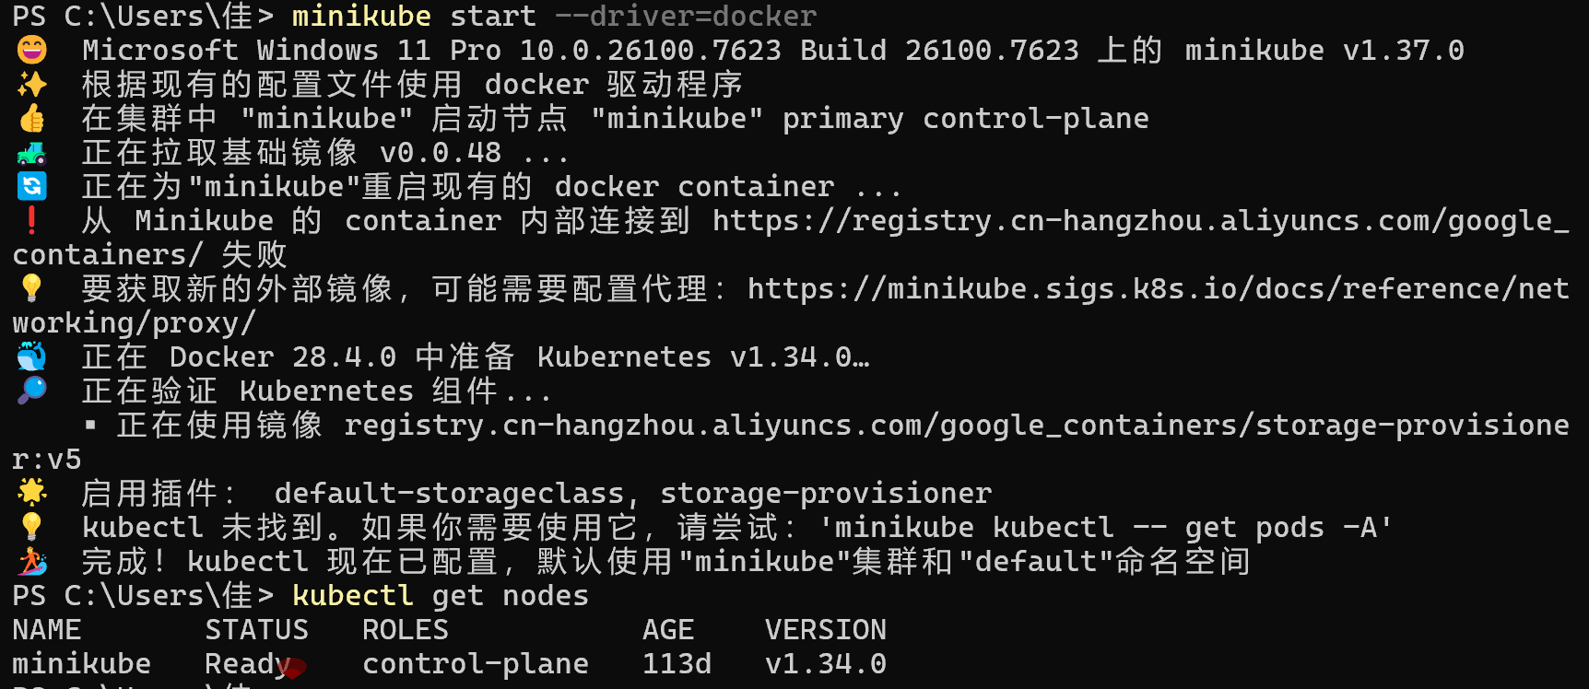
- Check cluster status
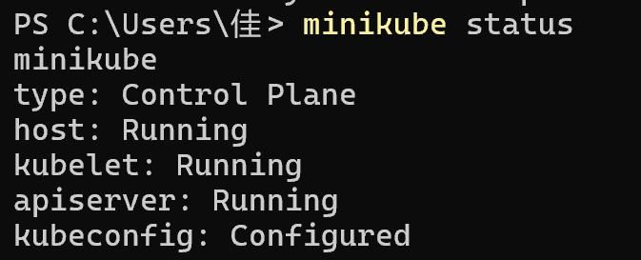
- Open Kubernetes Dashboard (optional, for visual management)

- Create Deployment (deploy application)
- Check Deployment and Pod status
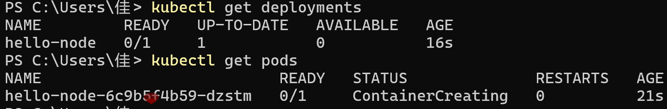
- View application logs
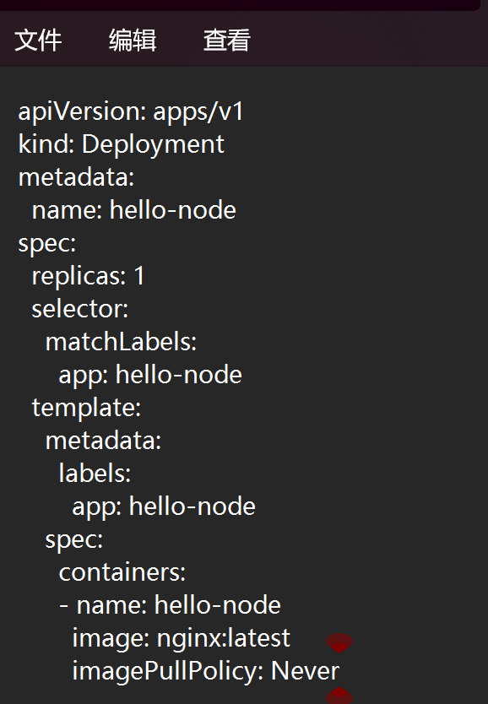
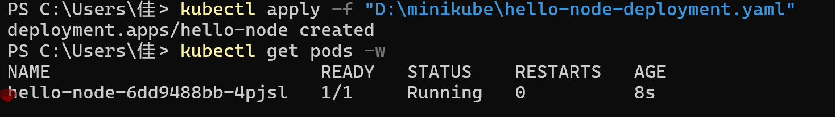
- Expose Service (make the application accessible externally)
- Access the application
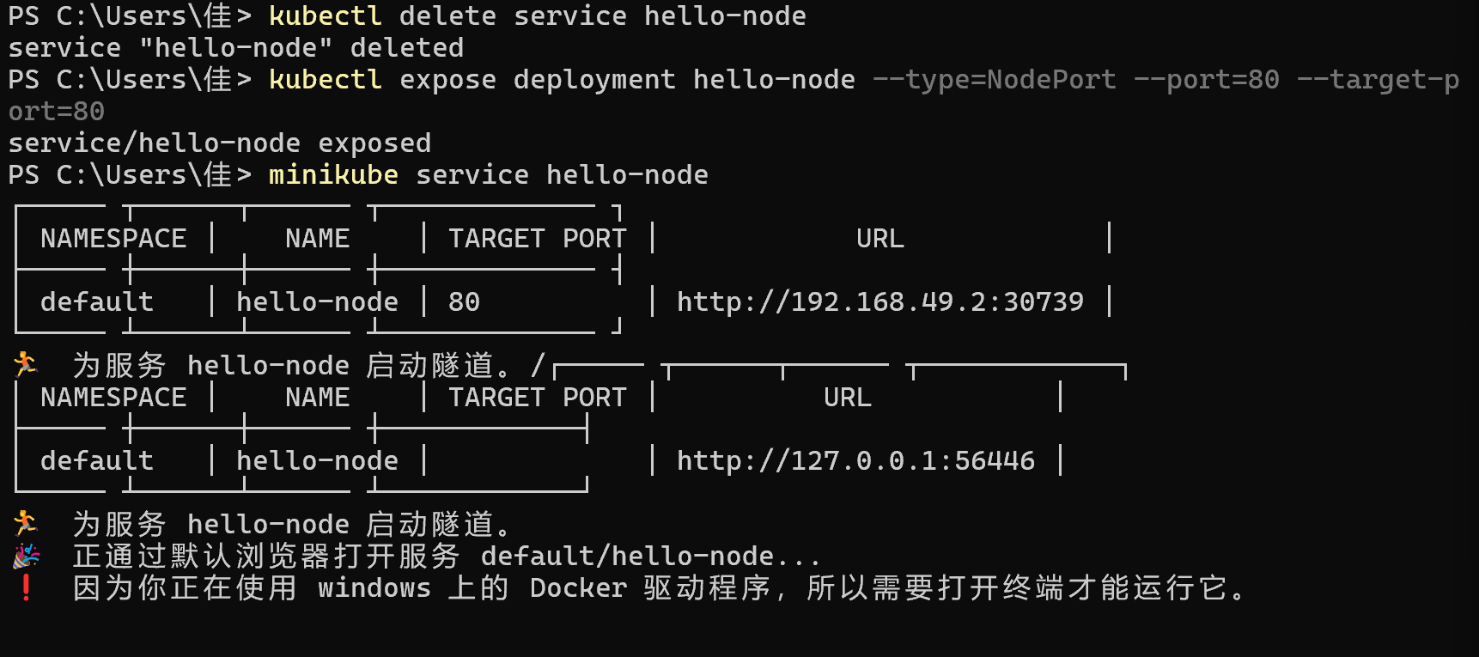
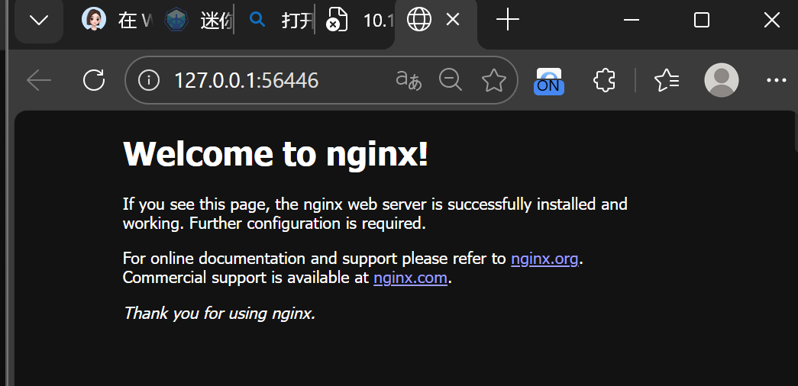
- Enable plugins (using metrics-server as an example, to monitor Pod resource usage)
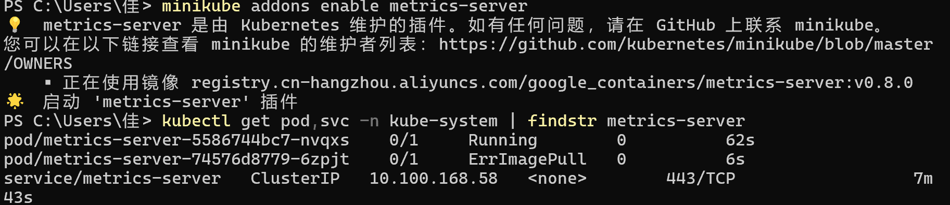
- Clean up resources
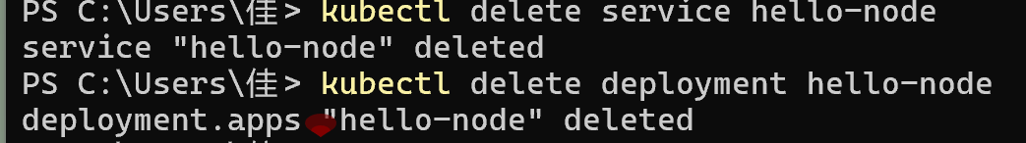
- Create a Deployment using kubectl
- Ensure the Minikube cluster is running
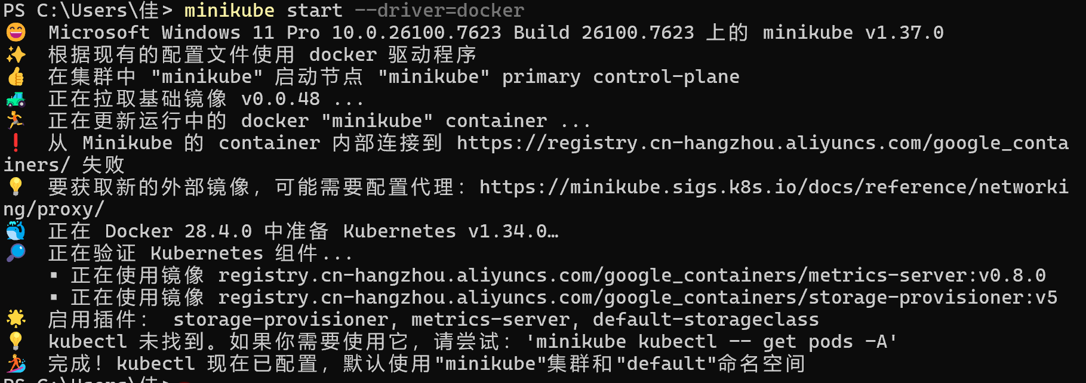
- Create a Deployment (deploy the kubernetes-bootcamp application)
- Check the status of the Deployment
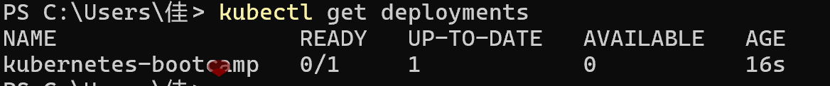
- View cluster nodes (to understand where the application is scheduled)
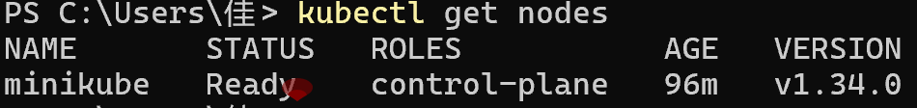
- Access the application via kubectl proxy (internal network proxy for Pods)
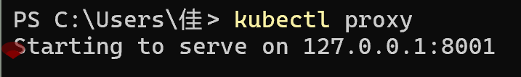
- Exploring Pods and Nodes
- View Pod details (including containers, IP, events, etc.)
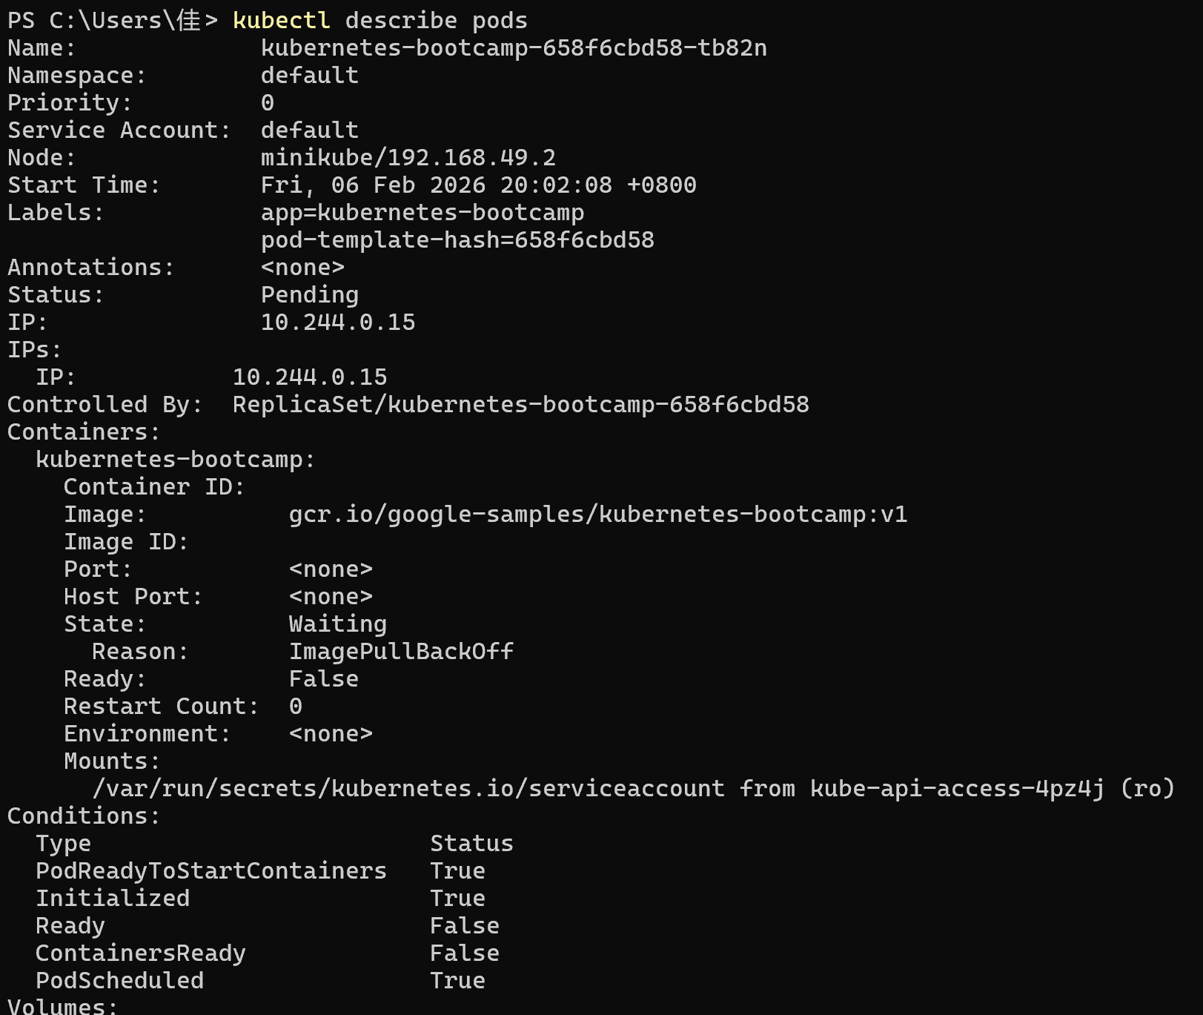
Containers: container name, image, port (e.g., 8080/TCP)
IP: Pod internal IP
Events: Pod lifecycle events
- View Node details (understand node resources and running components)
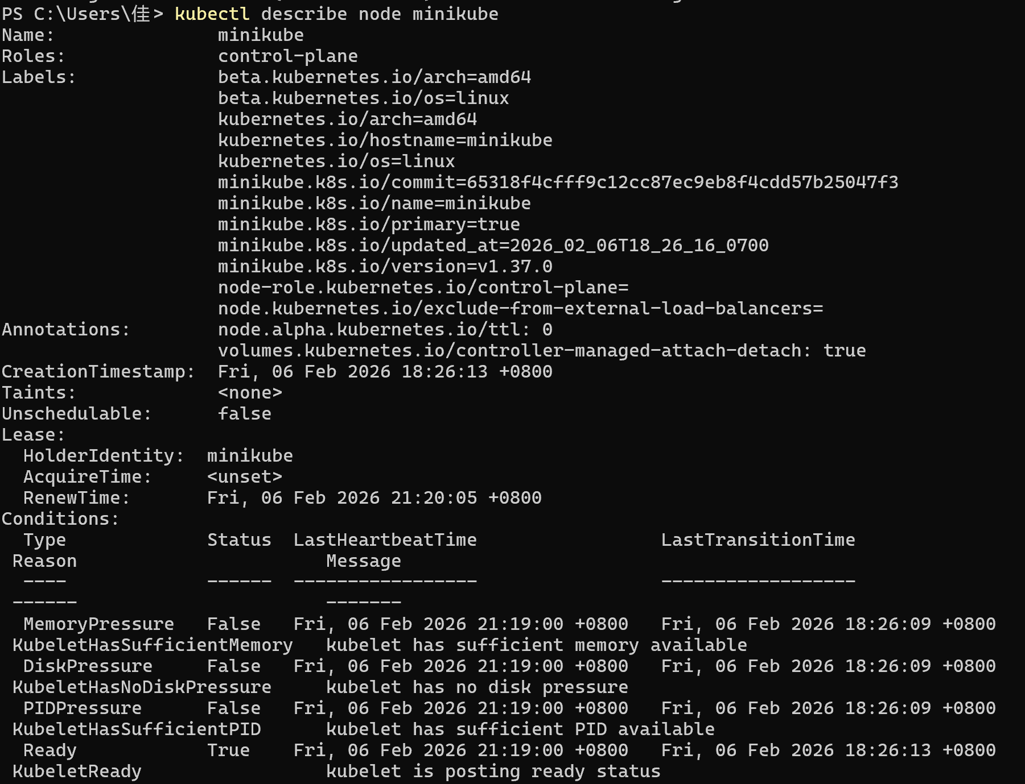
Capacity: Total resources of the node (CPU, memory)
Allocatable: Resources of the node that can be allocated to Pods
Pods: All Pods running on the node (including system components in the kube-system namespace)
- Execute commands inside the Pod (check environment variables, files, etc.)
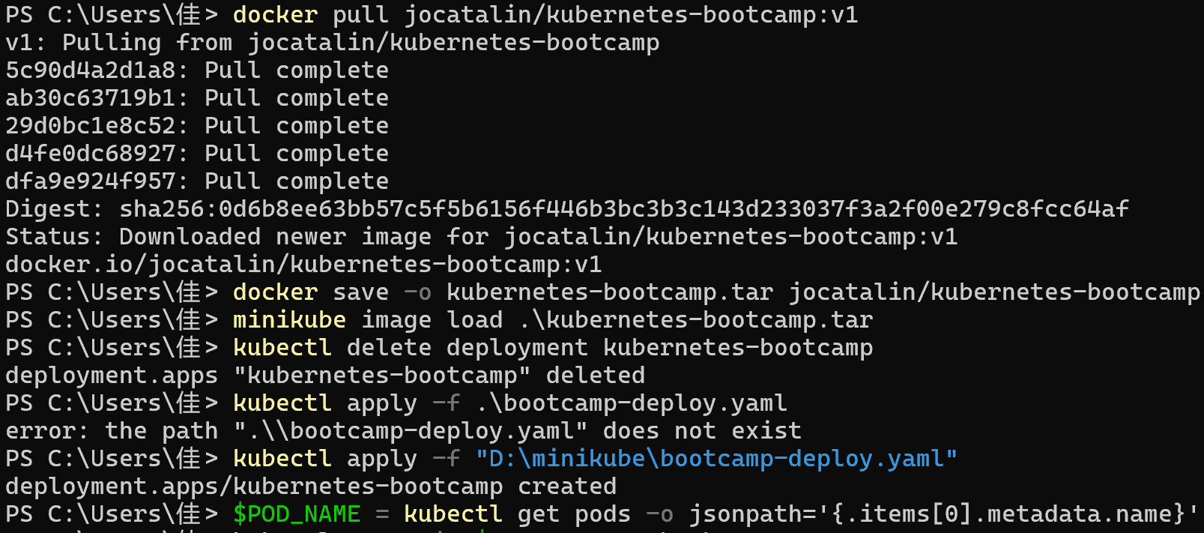
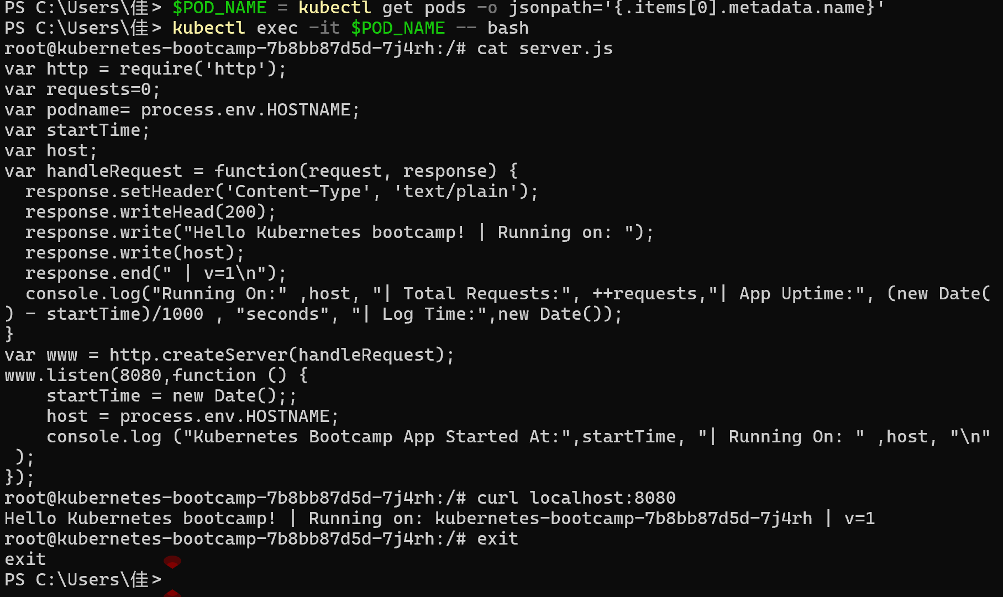
- Expose applications using Service
- Expose Deployment as a NodePort service
- Check the Service status
TYPE: Service Type (NodePort)
PORT(S): Internal Port (8080) / External NodePort Port (30369, randomly assigned, range 30000-32767)
- Get detailed Service information (including NodePort port)
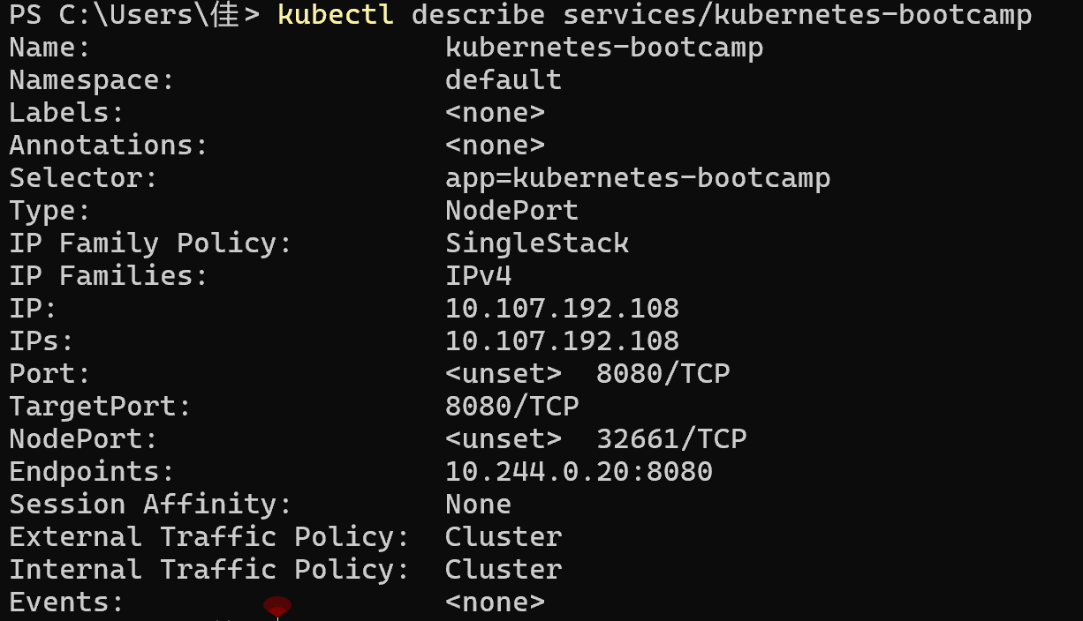
- Access the exposed service (on Windows, use Minikube IP and NodePort)
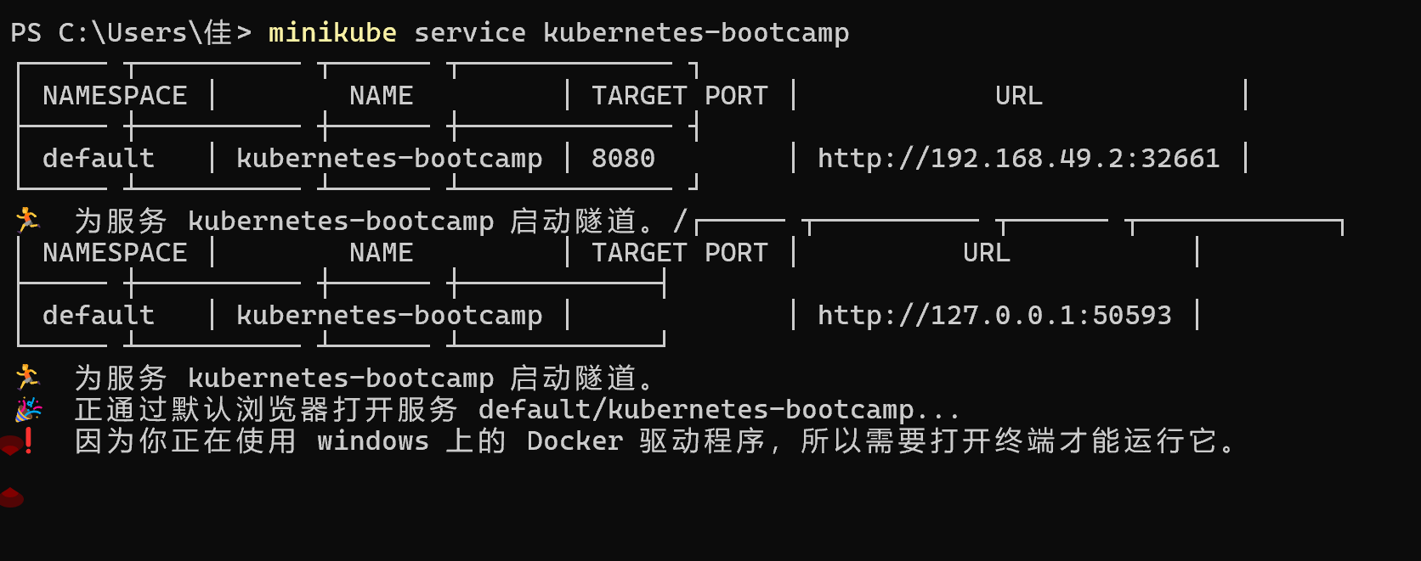
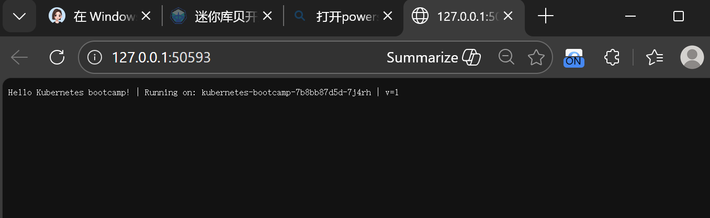
- Use labels to filter resources (Service and Pod are associated through labels)
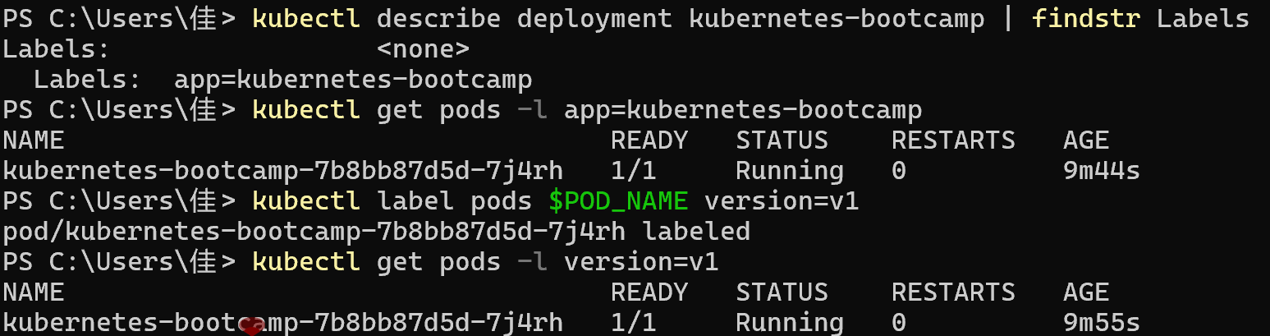
- Delete the Service and verify
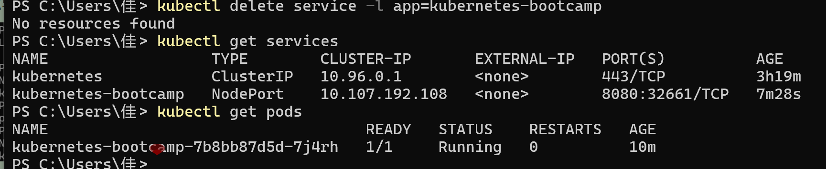
- Application scaling
- Ensure the Service is created (LoadBalancer type, for load balancing verification)
- Check the current number of Deployment replicas
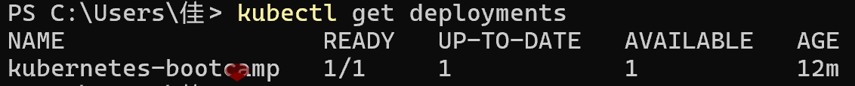
- Scale up: adjust the number of replicas to 4
- Verify the scaling up result
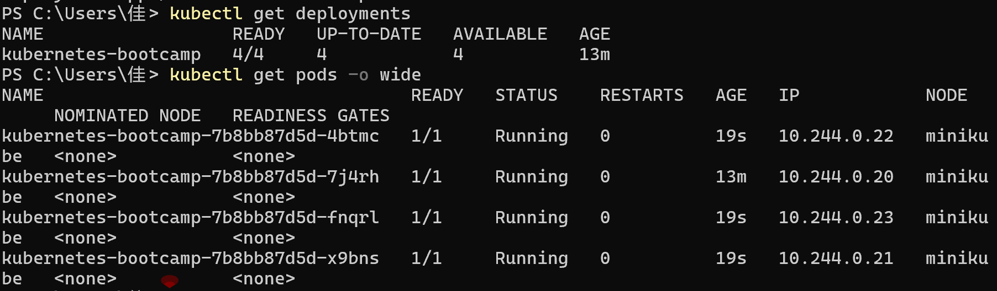
- Verify load balancing (the Service distributes traffic to multiple Pods)
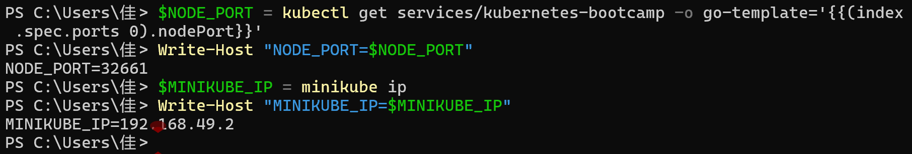
- Scale down: adjust the number of replicas to 2
- Verify the scaling down result
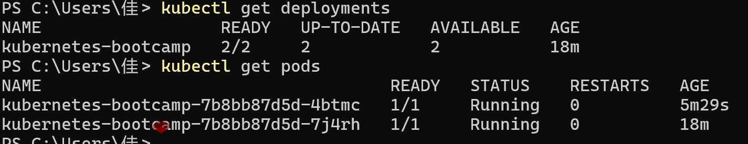
- Rolling Update and Rollback
- Check the current application image version
- Rolling update: upgrade the image version to v2
- View the update process (Pods are replaced step by step)
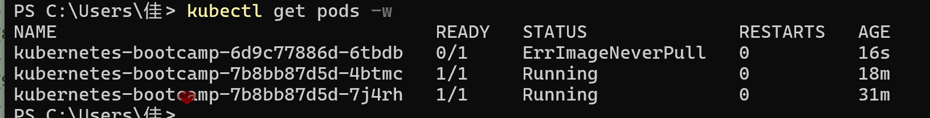
- Verify the update results
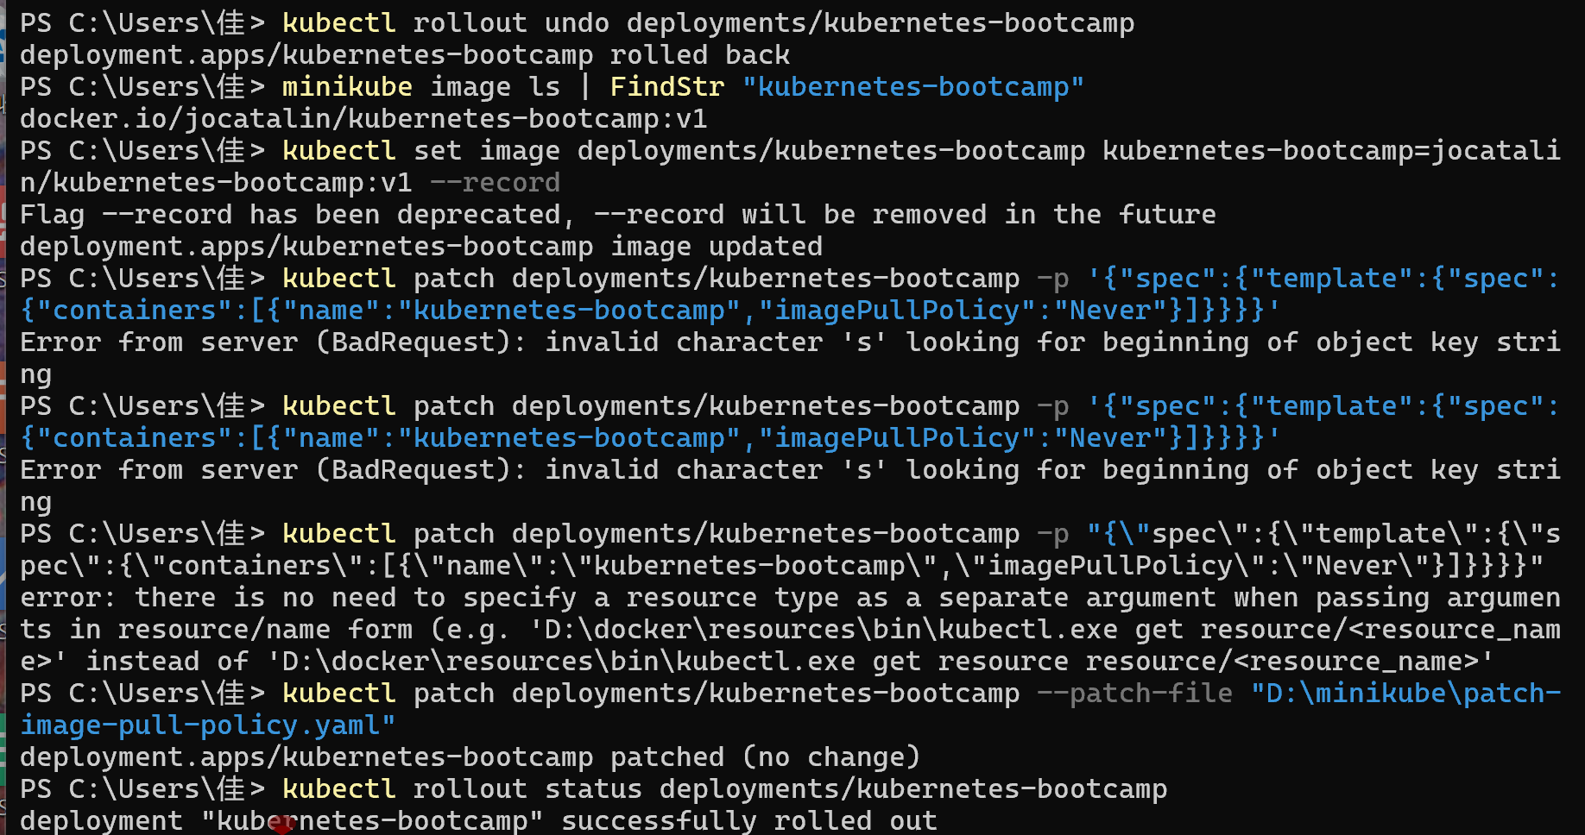
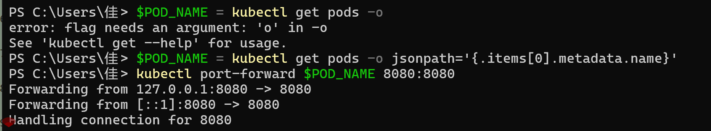
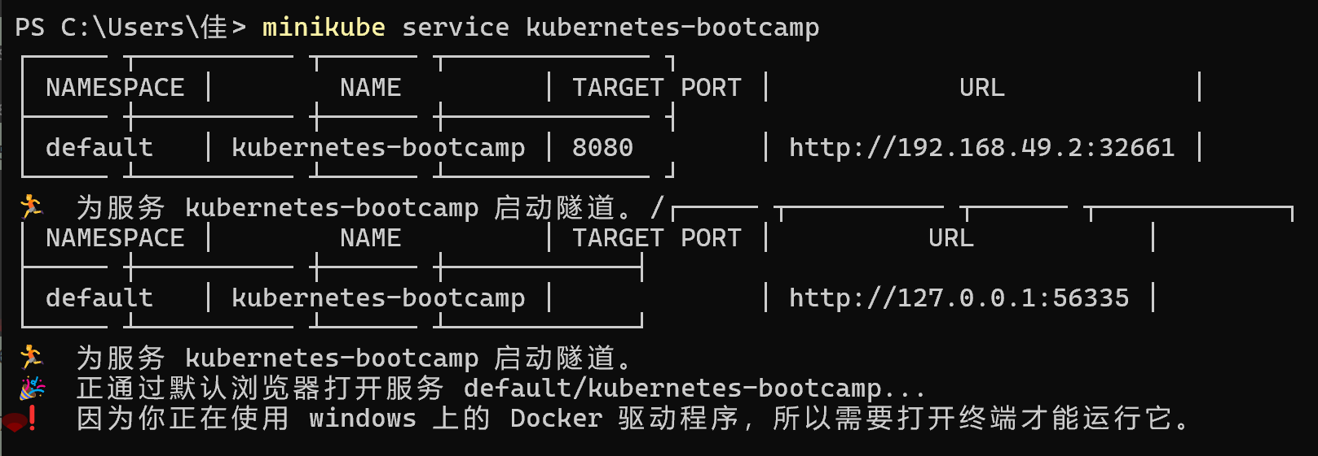
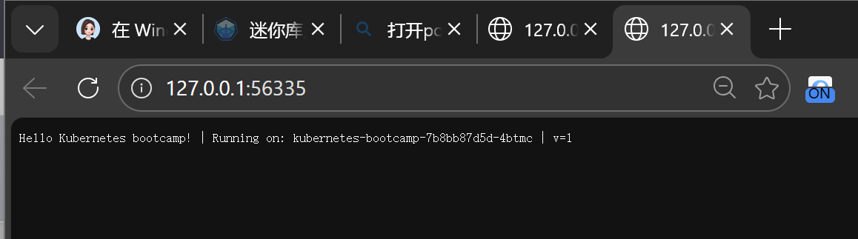
- Simulate update failure (using a non-existent image version v10)
- Simulate update failure (using a non-existent image version v10)
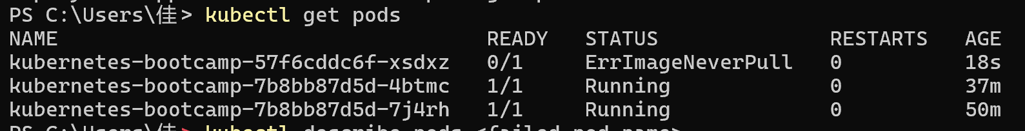
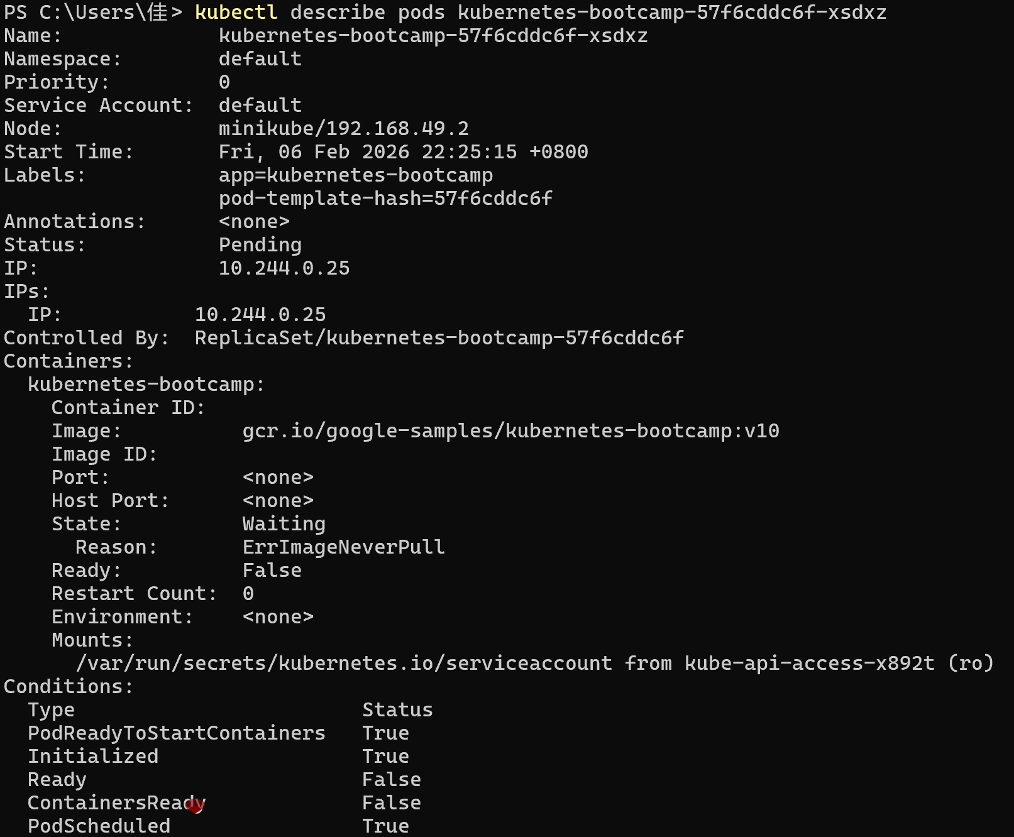
- Rollback to the previous stable version (v2)
- Verify the rollback results
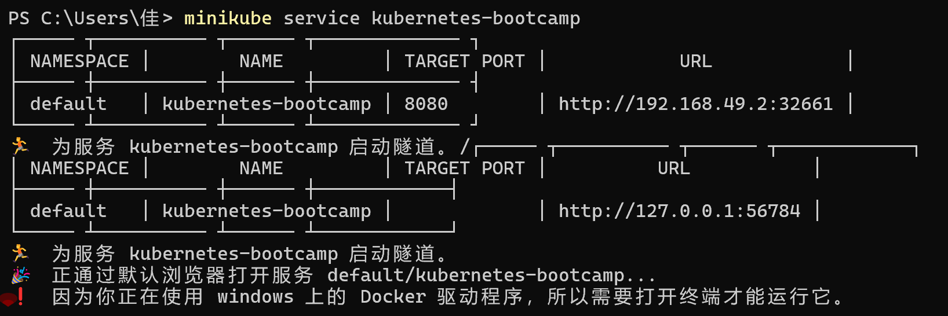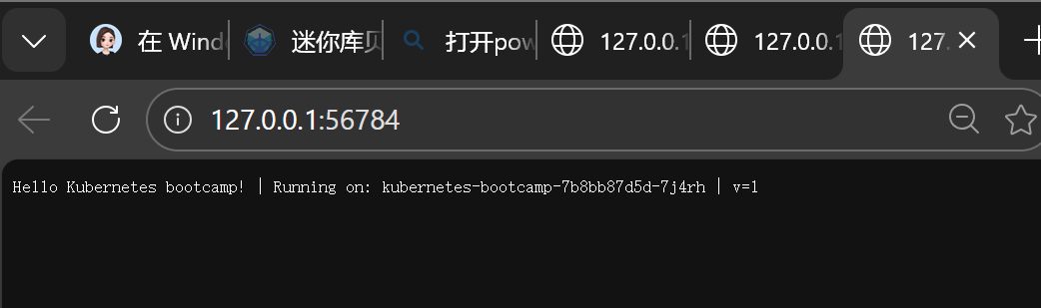
- Clean up resources (after the experiment)
